**10 - R710 Proxmox - Cloud init – for cloning VMs**

**Log in to Proxmox:**

1. In Firefox, go to : https://192.168.124.**201**:8006

User: root

Password : <whatever>

**Cloud init – for cloning VM’s**

1. Then **creating** a template from this with cloud-init, see video:  
    Creating a template in Proxmox Virtual Environment with cloud-init support  
    <https://www.youtube.com/watch?v=8qwnXd1yRK4>
2. The commands to enter from the video:  
     
   sudo apt install cloud-init  
     
   sudo rm /etc/machine-id  
   sudo touch /etc/machine-id  
   cat /var/lib/dbus/machine-id  
   sudo rm /var/lib/dbus/machine-id  
   sudo ln -s /etc/machine-id /var/lib/dbus/machine-id  
   ls -l /var/lib/dbus/machine-id  
    shows:  
   lrwxrwxrwx 1 root root 15 Mar 13 11:12 /var/lib/dbus/machine-id -> /etc/machine-id  
     
   cat /etc/machine-id  
    should return an empty file  
     
   sudo apt clean
3. All the configuration for the virtual machine is now done to allow the creating of a template.
4. Now power off the VM
5. We will now create what is called “a cloud init drive”
6. Goto Hardware/Add/CloudInit Drive:  
   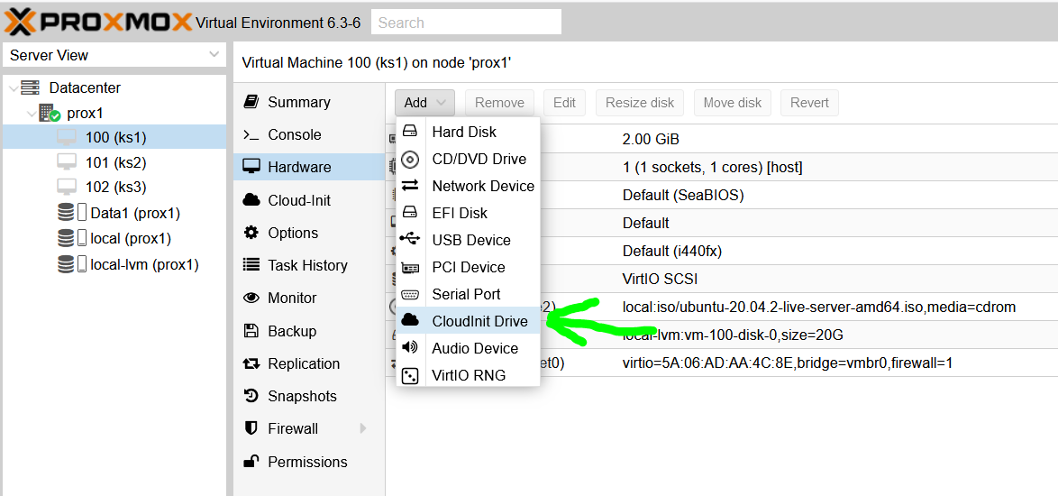  
   to get:  
   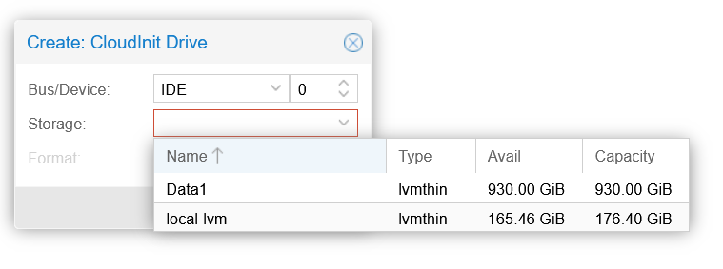  
   and click on **local-lvm**, to get:  
   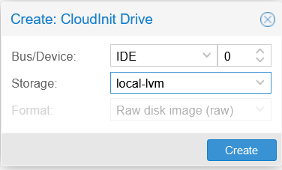  
   and click on Create
7. Now go to this screen, to edit User and Password:  
   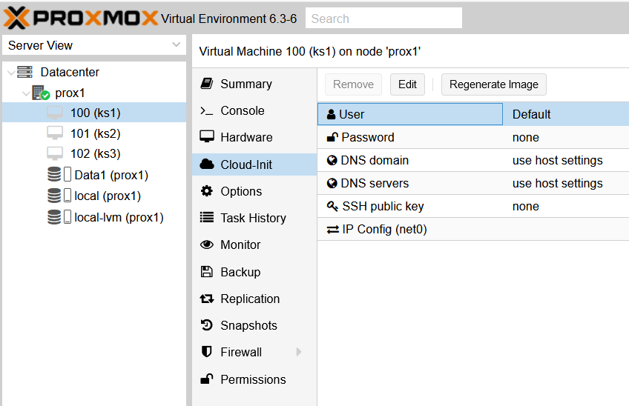  
   to get:  
   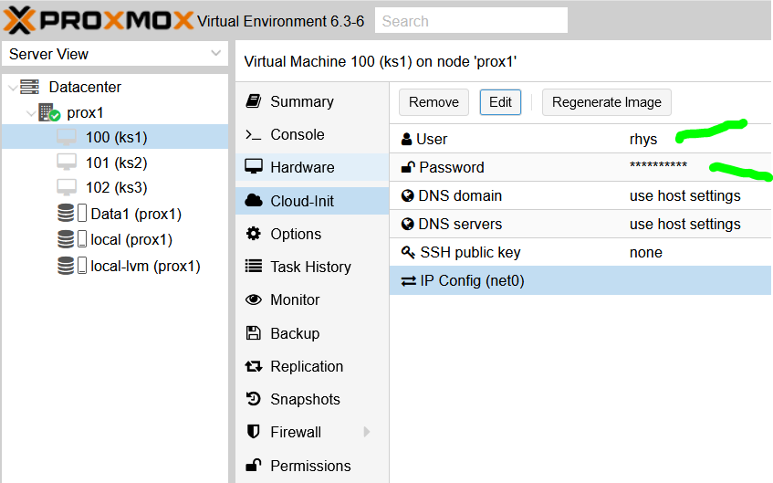
8. Now click on Regenerate Image
9. The VM template creation is now complete.